|  |
| --- |
| **Movie Ticket Booking System** |
| ADARSH GUPTA |
| Movie ticket booking system to make the user experience way too easy and friendly. Developed with NetBeans IDE for front-end and MYSQL for back-end. |
|  |

**INTRODUCTION**

Movie ticket booking system is basically made for providing the customers an anytime and anywhere service for booking cinema tickets and providing information about the movies and their schedule online.

Admin can use Online Movie Ticket Booking System Project to insert and delete data such as movie description, movie schedule which will update the related webpage and will be accessible by the customers.

Movie Ticket Booking System provide another way for the customers to buy cinema ticket. This system reduces work load on customers, it is an automatic ticket booking system.

This system is basically aimed to provide complete information of the movie and schedule to the customer, according to which he can book the tickets.

**ABOUT THIS PROJECT**

This project is developed with NetBeans IDE and MYSQL. So, question arises what is NetBeans IDE and MYSQL?

NetBeans IDE lets you quickly and easily develop Java desktop, mobile, and web applications, as well as HTML5 applications with HTML, JavaScript, and CSS. The IDE also provides a great set of tools for PHP and C/C++ developers. It is free and open source and has a large community of users and developers around the world.

MySQL Database Service is a fully managed database service to deploy cloud-native applications using the world’s most popular open-source database. It is 100% developed, managed and supported by the MySQL Team.

**EXPERIMENTAL TECHNIQUES & DISCUSSIONS**

In this project, we have created three frames. So, let’s start breaking down each frame one by one in order.

**1) Login Form**

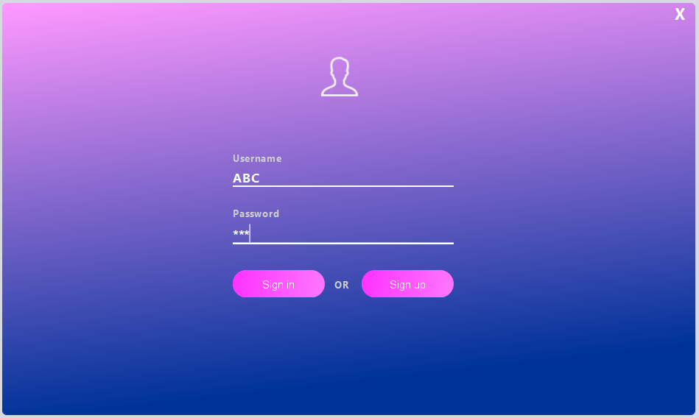

This is just a basic login form; it will give you access if relevant credentials are present in the database or you can sign up.

Wrong credentials: -

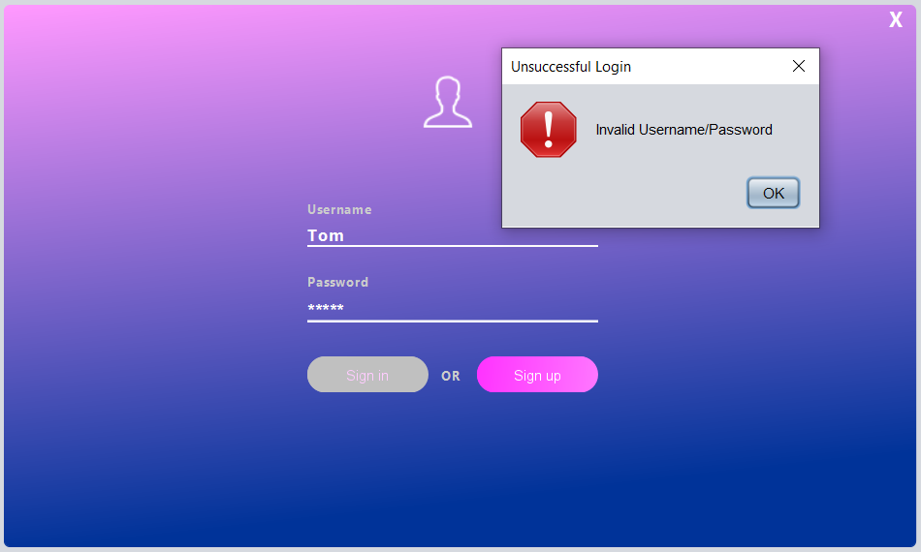

It will generate error if wrong credentials are provided.

Correct credentials: -

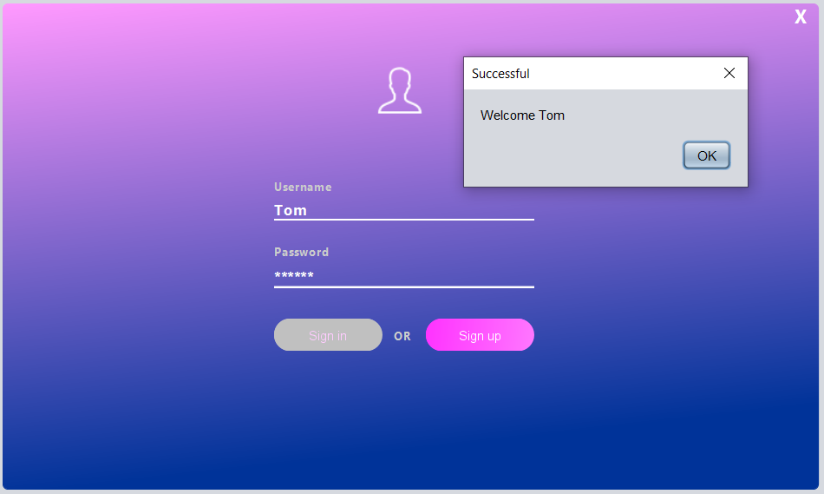

It will let you in if correct credentials are provided.

**2) Dashboard**

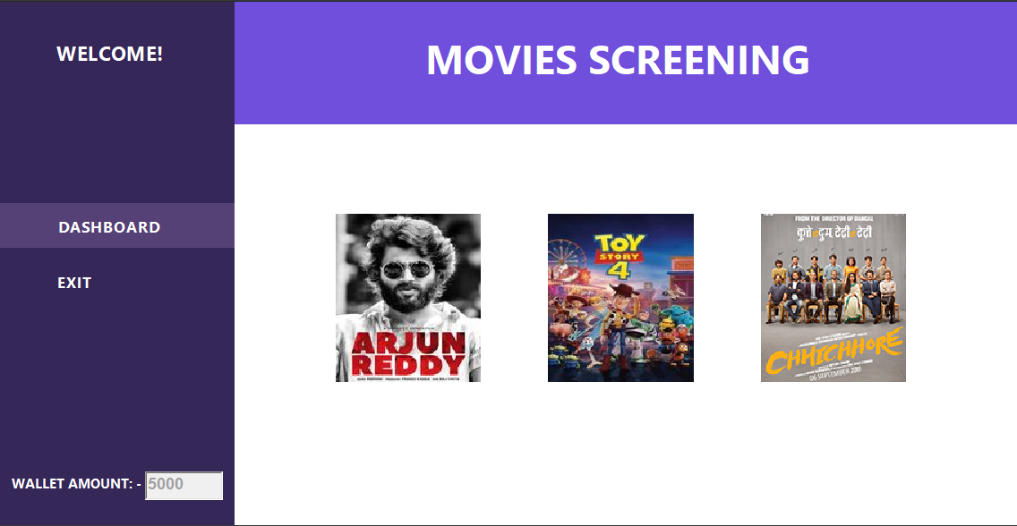

It will show all the movies that are currently screening and your wallet amount.

Let’s suppose user clicks on “Arjun Reddy” movie.

**3) Tickets booking**

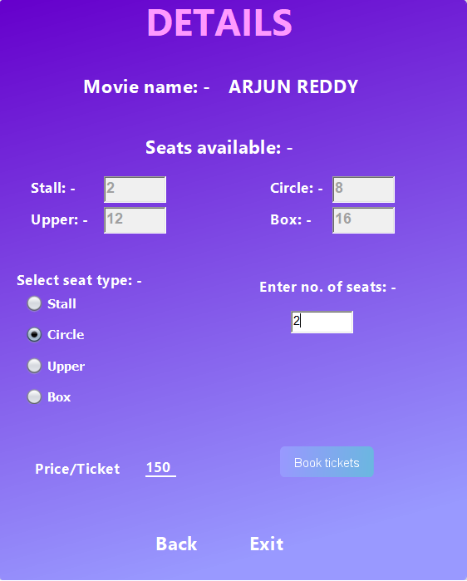

It will show the available number of seats, seat types, price of seats and other information. User can select the seat type and type numbers of seats he/she wants.

Book Tickets: -

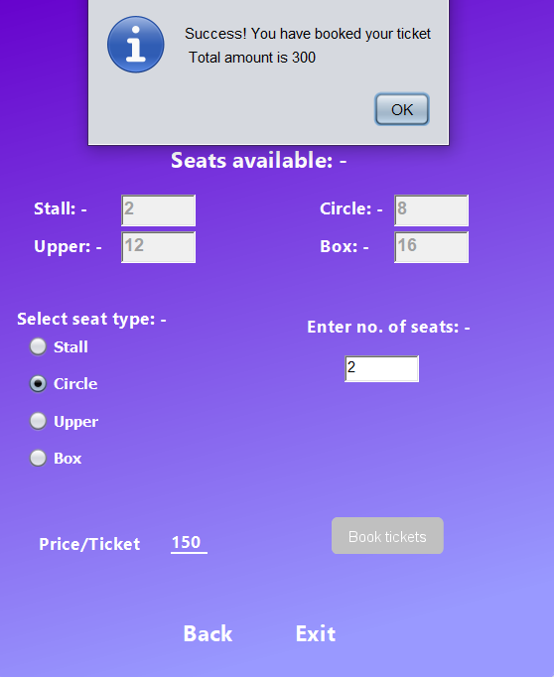

When user will click book tickets, it will deduct the respective amount from the wallet and reduce the same number of seats from that particular movie screening.

User can see their wallet money getting reduced by pressing “back” button.

**Summary**

NetBeans IDE is really a powerful tool to make Java,

HTML, CSS applications really fast. The IDE is designed to limit coding errors and facilitate error correction with tools such as the NetBeans Find Bugs to locate and fix common Java coding problems and Debugger to manage complex code with field watches, breakpoints and execution monitoring.

MYSQL is a great way to implement multiple user sessions simultaneously.

**In this project I learnt: -**

* Developed a user interface within the Java GUI Application using NetBeans IDE components such as Textbox, Label, Buttons, Table, Messagebox, etc.
* Parsing between multiple form application.